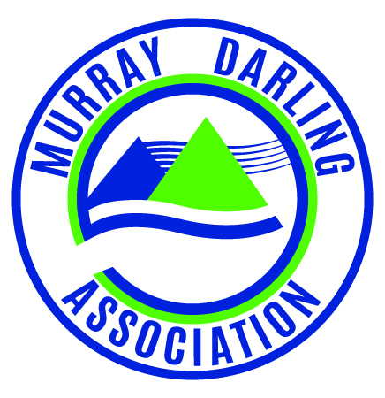
admin@mda.asn.au
www.mda.asn.au
T (03) 5480 3805
ABN: 64 636 490 493

463 High Street
P.O. Box 1268
Echuca, Vic 3564

3rd Floor, 553 Kiewa Street
P.O. Box 359
Albury, NSW 2640

Murray Darling Association Inc.

Ordinary Meeting of the Board
Monday 21 December 10.30 am (AEST)
Townsville - Skype

Minutes - MEETING No. 354

- ATTENDANCE
  - Present
Cr David Thurley | A/National President
Ms Emma Bradbury | Chief Executive Officer
Mr Des Bilske | Region 2 Chair
Cr Kevin Myers | Region 5 Chair
Cr Barry Featherston | Region 6 Chair
Cr Peter Jamieson | Region 7 Chair
Cr Paul Maytom | Region 9 Chair
Mr Murray Wood | Region 10 Chair

  - Apologies
Mr Rodney Button | Region 8 Chair

  - Declaration of Interests and Conflicts
None declared

1.4 David Thurley welcomed Des Bilske, Chair of Region 2 to the Board.

- PREVIOUS MINUTES

Motion: That the minutes of the previous meeting be accepted as true and accurate record, and posted on-line in accordance with usual procedure.

K Myers/P Maytom Carried

- BUSINESS ARISING
  - Board Resolutions and Action Items Table
The board noted the action items table.

It was resolved at the November meeting of the Board that board members provide to the executive a personally signed copy of the Code of Conduct and a Duty Statement, no later than the next board meeting of the MDA.

The Code of Conduct and the Board Member Duty Statement were adopted by the full board at the June 2015 board meeting.

Peter suggested that board members consider the Code of Conduct, and the Position Description; provide and further feedback they feel appropriate, and sign off on it at the next face to face meeting of the board to be held in February.
Motion: That all board members complete and sign off on the Code of Conduct and Duty Statement at the next face to face meeting of the board, scheduled for February.

P Jamieson/B Featherson Carried

- REPORTS
  - Region Reports No reports provided
  - Chief Executive Officer’s report No report provided
  - Finance Report No report provided

- GENERAL BUSINESS
  - Resignation of Greg Toll
The Board noted the correspondence received from … Greg Toll, advising the board of … Mr Toll’s resignation from the Murray Darling Association.

…

Motion: That the board
- accept the resignation of Mr Greg Toll
- …
- …

K Myers/B Featherston Carried

  - Meeting with Dept Ag and Water Resources

Board noted the invitation from Matthew Coulton senior advisor to the Minister for Ag and Water Resources to meet in Canberra. Discussion on the merits of a trip being organized to make that meeting and seek also to meet with the CEWH, and the MDBA early in the new year. CEO to pursue that objective, with a view to consolidating relationships in the interest strengthening the MDA’s position. Agreed that it will be helpful to have a whole of basin representative approach where possible.

Motion: That the MDA accept the invitation to meet with the Dept of Ag and Water Resources early in the new year, and that the Chief Executive Officer arrange further meetings and attendances to add value as appropriate.

B Featherson/M Wood Carried

- CLOSE 11.30am

*… indicates exclusion of information deemed confidential.

